PROJECT REPORT OF CO-OP Project at Industry (Module-2)
ON
Applications and Challenges of Large Language Models in Real-World Systems
submitted in partial fulfilment of the requirements for the award of degree of

BACHELOR OF ENGINEERING
In
COMPUTER SCIENCE AND ENGINEERING

Submitted by: Supervised By:
Dimple Khatri, Garima Dr. Rajar Takkar
2201991517, 2210991562


DEPARTMENT OF COMPUTER SCIENCE AND ENGINEERING

CHITKARA UNIVERSITY INSTITUTE OF ENGINEERING AND TECHNOLOGY
CHITKARA UNIVERSITY, PUNJAB, INDIA

CONTENTS

S.No. | Title | Page No.
 | Acknowledgement | 4
 | List of Figures and Tables | 4,5
 | Abstract | 5
 | Introduction | 5,6
 | Methodology | 6
 | Tools and Technologies | 6,7
 | Implementation | 7
 | Major Findings/Outcomes/Output/Results | 7
 | Conclusion and Future Scope | 8
 | References | 8,9
 | Appendices | 9

DECLARATION

I hereby certify that the work which is being presented in the project report entitled “Applications and Challenges of Large Language Models in Real-World Systems” in partial fulfilment of requirement for the award of the degree of Bachelor of Engineering (Computer Science and Engineering) submitted in the department of Computer Science and Engineering at Chitkara University Institute of Engineering and Technology, Chitkara University, Punjab, India, is an authentic record of my own work carried out under the supervision of Mr. Rajat Takkar. The matter presented in this project report has not been submitted in any other university/institute for the award of any degree.

Place: Rajpura Dimple Khatri, Garima

Date: 29 April 2026 2201991517, 2210991562

This is to certify that the above statement made by the candidate is correct to the best of my knowledge and belief.

Rajat Takkar
Assistant Professor
Department of Computer Science and Engineering
Chitkara University Institute of Engineering and Technology,
Chitkara University, Punjab, India

ACKNOWLEDGEMENT

I would like to express my sincere gratitude to my mentor, Dr. Rajat Takkar, for his continuous guidance, support, and valuable insights throughout the development of this project. His encouragement and suggestions played a crucial role in shaping this work.
I would also like to thank Chitkara University for providing the necessary resources and environment to successfully complete this project. I am grateful to my teammates for their collaboration, effort, and dedication.
Lastly, I would like to thank everyone who directly or indirectly contributed to the successful completion of this project.

LIST OF FIGURES AND TABLES
Figures:
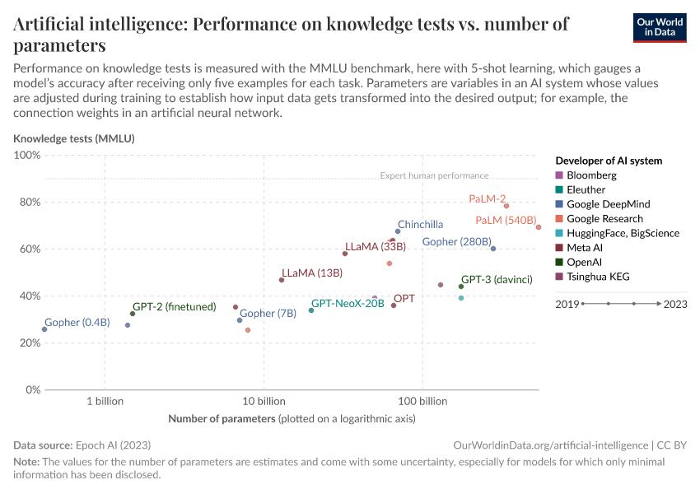

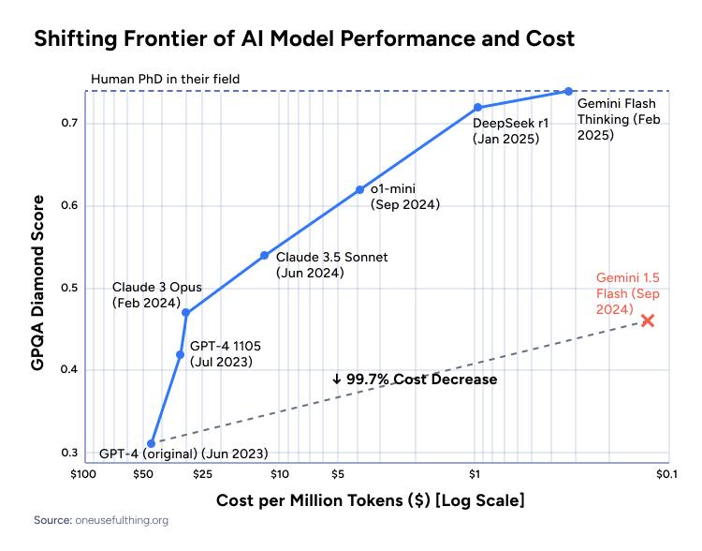
ABSTRACT
Large Language Models (LLMs) have emerged as a transformative technology in artificial intelligence, enabling applications such as text generation, summarization, and conversational systems. These models are widely used across industries including healthcare, education, finance, and customer support.
This study explores the applications and challenges of LLMs in real-world systems. The research focuses on understanding their performance, scalability, and limitations such as bias, hallucination, and high computational requirements.
The methodology includes literature review, comparative analysis, and evaluation of different LLM-based systems. Key findings highlight that while LLMs significantly enhance automation and user interaction, they also introduce concerns related to fairness, reliability, and interpretability.
The study concludes that future advancements should focus on improving efficiency, reducing bias, and enhancing transparency to ensure responsible deployment of LLMs in real-world environments.

INTRODUCTION
Large Language Models (LLMs) have revolutionized the field of Natural Language Processing (NLP) by enabling machines to understand and generate human-like text. These models, built using transformer architectures, have significantly improved tasks such as text generation, translation, summarization, and question answering.
In recent years, LLMs have been integrated into real-world systems across various domains. From chatbots in customer service to decision-support systems in healthcare, their impact is widespread.
However, despite their capabilities, LLMs face several challenges. These include bias in generated outputs, hallucination of incorrect information, high computational costs, and lack of interpretability. These challenges raise concerns about their reliability and ethical use.
This project aims to analyze the applications and challenges of LLMs, providing insights into their real-world impact and future potential.

METHODOLOGY
The methodology followed in this project includes:
1. Literature Review:
Existing research papers and articles on LLMs were studied to understand their architecture, applications, and limitations.
2. Comparative Analysis:
Different LLM-based systems such as ChatGPT, Gemini, and other AI tools were analyzed based on performance and usability.
3. Evaluation Metrics:
Performance was evaluated using factors such as accuracy, response quality, and reliability.
4. Analysis of Challenges:
Key challenges such as bias, hallucination, and computational requirements were identified and studied.
This structured approach helped in understanding both theoretical and practical aspects of LLMs.

TOOLS AND TECHNOLOGIES
The project utilized the following tools and technologies:
- Python: For data analysis and experimentation
- Natural Language Processing (NLP): Core concept for understanding language models
- Transformer Architecture: Used in modern LLMs
- Machine Learning: For model training and evaluation
- Online AI Platforms (ChatGPT, Gemini): For comparative analysis

IMPLEMENTATION
The implementation phase involved studying and analyzing different LLM-based systems.
Various AI platforms were used to generate responses for different prompts. The outputs were observed and compared to evaluate performance and identify limitations.
The study focused on:
- Response accuracy
- Context understanding
- Consistency of outputs
Observations were recorded and analyzed to derive meaningful insights about model behavior in real-world scenarios.

MAJOR FINDINGS AND OUTCOMES
The study revealed that:
- LLMs perform exceptionally well in tasks like text generation and summarization.
- They provide fast and scalable solutions for real-world applications.
- However, they may generate incorrect or misleading information (hallucination).
- Bias in training data can influence outputs.
- Performance depends heavily on prompt design.
LLMs demonstrate high efficiency and accuracy in real-world applications, but challenges like bias, hallucination, and computational cost still persist.
Overall, LLMs are powerful but require careful usage and monitoring.

CONCLUSION AND FUTURE SCOPE
- This project concludes that Large Language Models have significant potential in transforming real-world systems. They enhance productivity, automate tasks, and improve user interaction.
- However, challenges such as bias, hallucination, and high computational cost must be addressed.
Future Scope:
- - Development of more efficient models
- - Reduction of bias in outputs
- - Improved explainability and transparency
- - Integration with real-time data sources

REFERENCES
- A. Vaswani et al., “Attention is All You Need,” in Advances in Neural Information Processing Systems (NeurIPS), 2017.
- J. Devlin, M. Chang, K. Lee, and K. Toutanova, “BERT: Pre-training of Deep Bidirectional Transformers for Language Understanding,” in NAACL, 2019.
- T. Brown et al., “Language Models are Few-Shot Learners,” in NeurIPS, 2020.
- OpenAI, “GPT-4 Technical Report,” 2023. [Online]. Available: https: //arxiv.org/abs/2303.08774
- P. Lewis et al., “Retrieval-Augmented Generation for KnowledgeIntensive NLP Tasks,” in NeurIPS, 2020.
- L. Ouyang et al., “Training Language Models to Follow Instructions with Human Feedback,” in NeurIPS, 2022.
- S. Bender et al., “On the Dangers of Stochastic Parrots: Can Language Models Be Too Big?” in FAccT, 2021.
- M. Bommasani et al., “On the Opportunities and Risks of Foundation Models,” Stanford CRFM, 2021.
- Y. Liu et al., “RoBERTa: A Robustly Optimized BERT Pretraining Approach,” arXiv, 2019.
- J. Wei et al., “Chain-of-Thought Prompting Elicits Reasoning in Large Language Models,” 2022.
- H. Touvron et al., “LLaMA: Open and Efficient Foundation Language Models,” arXiv preprint arXiv:2302.13971, 2023.
- R. Taori et al., “Stanford Alpaca: An Instruction-following LLaMA Model,” 2023. [Online]. Available: https://crfm.stanford.edu/2023/03/13/ alpaca.html
- S. Zhang et al., “OPT: Open Pre-trained Transformer Language Models,” Meta AI, 2022.
- J. Hoffmann et al., “Training Compute-Optimal Large Language Models,” DeepMind, 2022.
- S. Chowdhery et al., “PaLM: Scaling Language Modeling with Pathways,” Google Research, 2022.
- Y. Tay et al., “UL2: Unifying Language Learning Paradigms,” arXiv preprint arXiv:2205.05131, 2022.
- R. Rae et al., “Scaling Language Models: Methods, Analysis & Insights from Training Gopher,” DeepMind, 2021.
- A. Madaan et al., “Self-Refine: Iterative Refinement with SelfFeedback,” NeurIPS Workshop, 2023.
- X. Wang et al., “Self-Consistency Improves Chain of Thought Reasoning in Language Models,” 2022.
- S. Thoppilan et al., “LaMDA: Language Models for Dialog Applications,” Google AI, 2022.

APPENDICES
The appendix includes supporting materials used in the project:
- Sample prompts used for testing
- Output responses from AI systems
- Comparative tables
- Additional notes and observations

